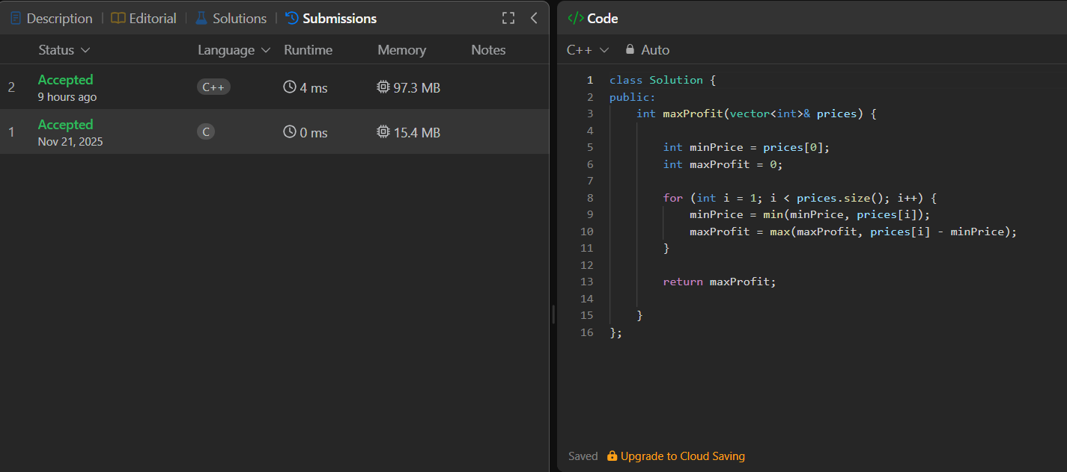
class Solution {
public:
int maxProfit(vector<int>& prices) {

int minPrice = prices[0];
int maxProfit = 0;

for (int i = 1; i < prices.size(); i++) {
minPrice = min(minPrice, prices[i]);
maxProfit = max(maxProfit, prices[i] - minPrice);
}

return maxProfit;

}
};

